**Assignment 1**

**Flexbox Assignment**

1. **Describe the main differences between the CSS Flexbox layout and the CSS Grid layout model. When would you choose to use one over the other?**

**Ans: Introduction to Differences:**

* **Flexbox is designed for one-dimensional layouts. It works either in a row or a column. It uses the concept of the main axis and cross axis. Items can be aligned along these axes.**
* **Flexbox adjusts its items according to the content within them. It is ideal for situations where you want to distribute space among items in a container, even if their size is unknown or dynamic.**
* **It provides powerful alignment capabilities such as align-items, justify-content, and align-self. It is great or small-scale layouts, such as navigation bars, footers, or components within a larger design.**
* **Grid is designed for two-dimensional layouts. It works both in rows and columns, allows you to control both dimensions simultaneously.**
* **Grid allows for the creation of complex layouts, independent of the content size. It provides a systematic approach to design a webpage.**
* **Items can be placed precisely in a grid cell or span multiple cells with properties like grid-column and grid-row.**

1. **Explain the role of following key properties in the Flexbox layout model:**
2. **justify-content: This property is used to align and distribute elements the flex items across the main axis. It has the following values: flex-start, flex-end, center, space-between, space-around and space-evenly.**
3. **align-items: This property is used to align and distribute elements the flex items across the cross axis. It has the following values: flex-start, flex-end, center, baseline and stretch.**
4. **gap: This property is used to set the gap between the flex items.**
5. **flex-direction: Each flex container has a direction attached to it. The items inside the container are arranged in that direction only. The default direction is row. We can change it to column, column-reverse, row-reverse.**
6. **flex-wrap: This property allows flex items to wrap in multiple lines.**
7. **Write a code to center a div using flexbox.**

**Ans: HTML Code:**

**<!DOCTYPE html>**

**<html lang="en">**

**<head>**

**<meta charset="UTF-8">**

**<meta name="viewport" content="width=device-width, initial-scale=1.0">**

**<link rel="stylesheet" href="style.css">**

**<title>Flexbox Assignment</title>**

**</head>**

**<body>**

**<h1 id="main-heading">Code to center a div using flexbox</h1>**

**<div class="container">**

**<div class="centered-div">Centered Div</div>**

**</div>**

**</body>**

**</html>**

**CSS Code:**

**\* {**

**margin: 0;**

**padding: 0;**

**box-sizing: border-box;**

**font-family: 'Times New Roman', Times, serif;**

**}**

**#main-heading {**

**text-align: center;**

**margin-top: 10px;**

**color: red;**

**}**

**.container {**

**display: flex;**

**justify-content: center;**

**align-items: center;**

**height: 80vh;**

**}**

**.centered-div {**

**width: 250px;**

**height: 250px;**

**background-color: rgb(44, 214, 44);**

**text-align: center;**

**line-height: 250px;**

**font-weight: bold;**

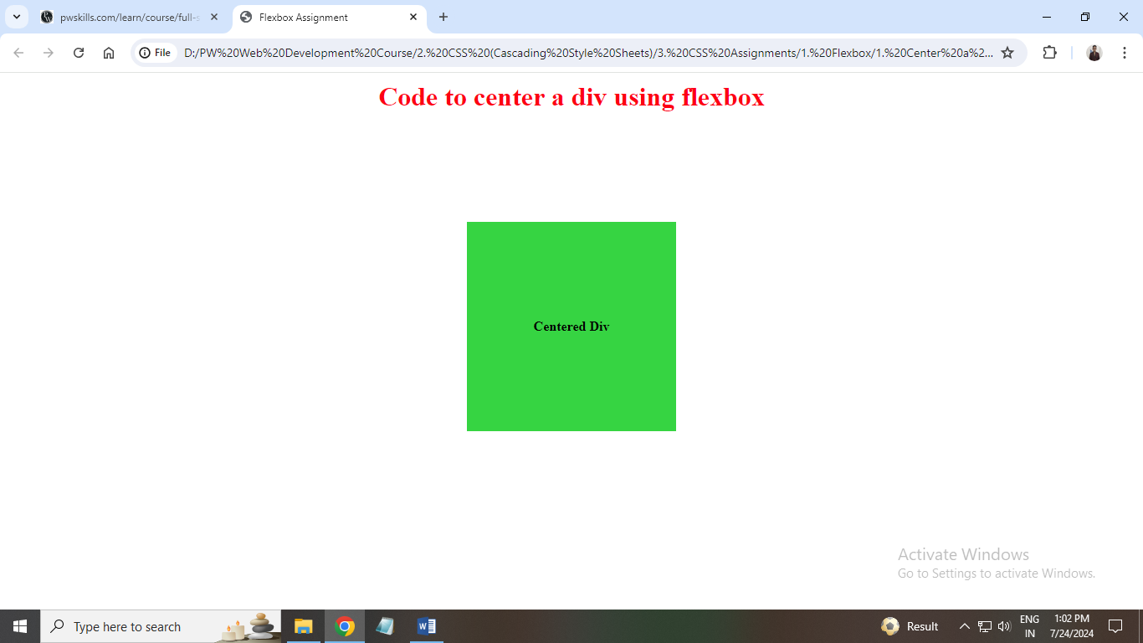**}**

1. **A client of yours wants to add your pricing section on their website to showcase their newly introduced premium plans.**

**Ans: HTML Code:**

**<!DOCTYPE html>**

**<html lang="en">**

**<head>**

**<meta charset="UTF-8">**

**<meta name="viewport" content="width=device-width, initial-scale=1.0">**

**<link href='https://unpkg.com/boxicons@2.1.4/css/boxicons.min.css'>**

**<link rel="stylesheet" href="style.css">**

**<title>Pricing Section</title>**

**</head>**

**<body>**

**<div id="pricing-section">**

**<div class="card">**

**<h1>Free Plan</h1>**

**<p class="info-text">For personal</p>**

**<h2 class="price">$0</h2>**

**<p><i class='bx bxs-check-circle'></i> 1 users included</p>**

**<p><i class='bx bxs-check-circle'></i> 4 Web mails</p>**

**<p><i class='bx bxs-check-circle'></i> Responsive Website</p>**

**<p><i class='bx bxs-check-circle'></i> Free SSL</p>**

**</div>**

**<div class="card" id="card-2">**

**<h1>Basic Plan</h1>**

**<p class="info-text">For small business</p>**

**<h2 class="price">$29</h2>**

**<p><i class='bx bxs-check-circle'></i> 4 users included</p>**

**<p><i class='bx bxs-check-circle'></i> 10 Web mails</p>**

**<p><i class='bx bxs-check-circle'></i> Responsive Website</p>**

**<p><i class='bx bxs-check-circle'></i> Free SSL</p>**

**</div>**

**<div class="card">**

**<h1>Pro Plan</h1>**

**<p class="info-text">For enterprise</p>**

**<h2 class="price">$49</h2>**

**<p><i class='bx bxs-check-circle'></i> Unlimited users</p>**

**<p><i class='bx bxs-check-circle'></i> Unlimited Web mails</p>**

**<p><i class='bx bxs-check-circle'></i> Responsive Website</p>**

**<p><i class='bx bxs-check-circle'></i> Free SSL + SEO</p>**

**</div>**

**</div>**

**</body>**

**</html>**

**CSS Code:**

**:root {**

**--text-color: #22313f;**

**--background-color: #22313f;**

**}**

**\* {**

**margin: 0;**

**padding: 0;**

**box-sizing: border-box;**

**font-family: 'Segoe UI', Tahoma, Geneva, Verdana, sans-serif;**

**}**

**#pricing-section {**

**display: flex;**

**justify-content: center;**

**align-items: center;**

**margin-top: 100px;**

**flex-wrap: wrap;**

**}**

**.card {**

**margin: 10px;**

**padding: 10px;**

**width: 300px;**

**height: 300px;**

**gap: 10px;**

**border-radius: 10px;**

**box-shadow: rgba(0, 0, 0, 0.24) 0px 3px 8px;**

**}**

**h1 {**

**letter-spacing: 0.5px;**

**color: var(--text-color);**

**}**

**h1,**

**h2 {**

**margin-left: 10px;**

**margin-top: 15px;**

**}**

**.price {**

**margin-top: 10px;**

**font-size: 32px;**

**letter-spacing: 1px;**

**}**

**.info-text {**

**margin-top: 1px;**

**font-size: 15px;**

**}**

**p {**

**margin-left: 10px;**

**margin-top: 10px;**

**font-weight: 500;**

**font-size: 18px;**

**}**

**#card-2 {**

**background-color: var(--background-color);**

**color: white;**

**}**

**#card-2 h1 {**

**color: white;**

**}**

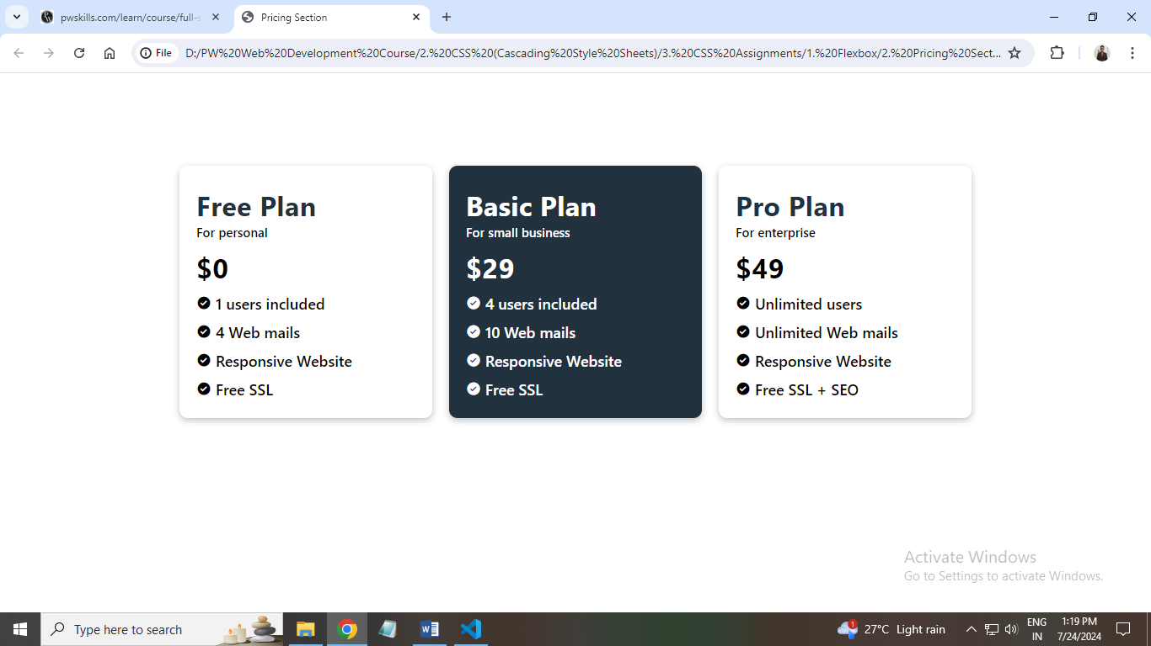

1. **Build an IRCTC Home Page Clone.**

**Ans: HTML Code:**

**<!DOCTYPE html>**

**<html lang="en">**

**<head>**

**<meta charset="UTF-8">**

**<meta name="viewport" content="width=device-width, initial-scale=1.0">**

**<link href='https://unpkg.com/boxicons@2.1.4/css/boxicons.min.css'>**

**<link rel="stylesheet" href="style.css">**

**<title>IRCTC</title>**

**</head>**

**<body>**

**<div class="main">**

**<div class="left-section">**

**<div class="nav">**

**<div class="logo">**

**<img src="irctc.png" alt="IRCTC Logo">**

**<img id="second-img" src="indian-railways.png" alt="Indian Railways Logo">**

**</div>**

**<div class="menu">**

**<div class="menu-item">**

**<a href="#">Ask Disha</a> <br>**

**<button class="btn-login">Login</button>**

**</div>**

**<div class="menu-item">**

**<a href="#">Contact Us</a> <br>**

**<button class="btn-reg">Register</button>**

**</div>**

**<div class="menu-item">**

**<a href="#">Alert</a> <br>**

**<button class="btn-reg">Agent Login</button>**

**</div>**

**</div>**

**</div>**

**<h1 id="main-heading">Indian Railways</h1>**

**<div class="sub-heading">**

**<p id="safety">Safety</p>**

**<p id="security">Security</p>**

**<p id="punctuality">Punctuality</p>**

**</div>**

**<div class="train-information">**

**<p id="book-ticket"><i class='bx bxs-train'></i> BOOK TICKET</p>**

**<p id="pnr-status"><i class='bx bx-check'></i> PNR Status</p>**

**<p id="bar-chart"><i class='bx bx-bar-chart'></i> Bar Charts</p>**

**</div>**

**<div class="train-location">**

**<div class="location-section">**

**<i class='bx bxs-location-plus'></i>**

**<div class="information-div">**

**<p>From <i class='bx bx-chevron-down'></i></p>**

**<h2>Bangalore</h2>**

**<p>KSR - Bangalore</p>**

**</div>**

**</div>**

**<i class='bx bx-transfer'></i>**

**<div class="location-section">**

**<i class='bx bxs-location-plus'></i>**

**<div class="information-div">**

**<p>To <i class='bx bx-chevron-down'></i></p>**

**<h2>Kasaragod</h2>**

**<p>KSD - Kasaragod</p>**

**</div>**

**</div>**

**</div>**

**<div class="train-location">**

**<div class="location-section">**

**<i class='bx bx-calendar-week'></i>**

**<div class="information-div">**

**<p>Date <i class='bx bx-chevron-down'></i></p>**

**<h2>1 Aug 23</h2>**

**<p>Tuesday</p>**

**</div>**

**</div>**

**<div class="location-section">**

**<i class='bx bxs-circle'></i>**

**<div class="information-div">**

**<p>Class <i class='bx bx-chevron-down'></i></p>**

**<h2>3A</h2>**

**<p>AC 3 Tier</p>**

**</div>**

**</div>**

**<div class="location-section">**

**<i class='bx bxs-package'></i>**

**<div class="information-div">**

**<p>Seat Type <i class='bx bx-chevron-down'></i></p>**

**<h2>TATKAL</h2>**

**<p>AC 3 Tier</p>**

**</div>**

**</div>**

**</div>**

**<button id="search-button">Search Train <i class='bx bx-right-arrow-alt' ></i></button>**

**</div>**

**<div class="right-section">**

**<img src="train.png" alt="Train">**

**</div>**

**</div>**

**</body>**

**</html>**

**CSS Code:**

**html,**

**body {**

**margin: 0;**

**padding: 0;**

**font-family: 'Times New Roman', Times, serif;**

**}**

**.main {**

**display: flex;**

**width: 100%;**

**}**

**.left-section {**

**display: flex;**

**flex-direction: column;**

**width: 60%;**

**}**

**.right-section {**

**display: flex;**

**flex-direction: column;**

**width: 40%;**

**height: 100vh;**

**}**

**.logo {**

**position: relative;**

**width: 168.31px;**

**height: 81.11px;**

**}**

**.logo img {**

**height: 81.11px;**

**width: 81.11px;**

**}**

**#second-img {**

**position: absolute;**

**left: 98.31px;**

**}**

**img {**

**height: 100vh;**

**width: 100%;**

**}**

**.nav {**

**display: flex;**

**flex-direction: row;**

**width: 100%;**

**margin: 40px 60px;**

**line-height: 34px;**

**}**

**.menu {**

**display: flex;**

**width: 100%;**

**justify-content: center;**

**}**

**.menu-item {**

**margin: 0 10px;**

**}**

**.menu-item button{**

**cursor: pointer;**

**}**

**a {**

**text-decoration: none;**

**color: #333333;**

**font-size: 23px;**

**font-weight: 500;**

**}**

**.btn-login {**

**background-color: #FB792B;**

**border-radius: 5.07px;**

**padding: 10.14px 15.21px 10.14px 15.21px;**

**color: #ffffff;**

**font-size: 15.21px;**

**border: none;**

**}**

**.btn-reg {**

**background-color: #ffffff;**

**border-radius: 5.07px;**

**padding: 10.14px 15.21px 10.14px 15.21px;**

**color: #333333;**

**font-size: 15.21px;**

**border: 1px solid #333333;**

**}**

**#main-heading {**

**margin: 0 55px;**

**font-size: 50px;**

**}**

**.sub-heading {**

**display: flex;**

**margin: 0 55px;**

**gap: 15px;**

**font-size: 25px;**

**font-weight: 500;**

**}**

**#safety {**

**color: green;**

**}**

**#security {**

**color: #FB792B;**

**}**

**#punctuality {**

**color: blue;**

**}**

**.train-information {**

**margin: 0 55px;**

**font-weight: 500;**

**display: flex;**

**gap: 20px;**

**font-size: 20px;**

**}**

**.bx-check, .bx-bar-chart, .bxs-train {**

**font-size: 20px;**

**}**

**#book-ticket, #pnr-status, #bar-chart {**

**border: 2px solid black;**

**padding: 10px;**

**}**

**#book-ticket {**

**background-color: #030733;**

**color: #ffffff;**

**}**

**.train-location {**

**display: flex;**

**justify-content: space-evenly;**

**padding: 20px;**

**border: 1px solid #ccc;**

**border-radius: 5px;**

**background-color: #f9f9f9;**

**margin-top: 15px;**

**margin-left: 55px;**

**margin-right: 55px;**

**}**

**.location-section {**

**display: flex;**

**align-items: center;**

**}**

**.location-section i {**

**font-size: 24px;**

**margin-right: 15px;**

**}**

**.information-div {**

**display: flex;**

**flex-direction: column;**

**align-items: flex-start;**

**}**

**.information-div p, .information-div h2 {**

**margin: 0;**

**}**

**.information-div p {**

**font-size: 14px;**

**color: #666;**

**}**

**.information-div h2 {**

**font-size: 20px;**

**color: #333;**

**}**

**.bx-transfer {**

**font-size: 35px;**

**margin-top: 15px;**

**}**

**#search-button {**

**background-color: rgb(46, 192, 46);**

**color: #ffffff;**

**padding: 20px 20px;**

**border: none;**

**border-radius: 5px;**

**font-size: 25px;**

**cursor: pointer;**

**width: 700px;**

**margin: 15px auto;**

**}**

**.bx-right-arrow-alt {**

**font-size: 24px;**

**}**

